COMMUNITY SERVICE PROJECT REPORT
ON
WATER FACILITIES AND DRINKING WATER AVAILABILITY

A project Report Submitted
As part of the Curriculum for the degree of
BACHELOR OF SCIENCE
By
Shaik. Ghousiya
(Roll No:20440312032 )
Class:1 BSc(M.E.CS)
2020-2021
Under the guidance of the Mentor
Dr. Bhusireddy Swaroopa
Lecturer in Mathematics


DEPARTMENT OF MATHEMATICS
SKR & SKR GOVERNMENT DEGREE COLLEGE FOR WOMEN (A)
JUNE -2022

CERTIFICATE

This is certified that the “Community Service Project on “Water Facilities And Drinking Water Availability” is the bonafide work done by shaik. Ghousiya, (Roll No:20440312032) duration of one month (May-June 2022) as part of curriculum for the partial fulfillment of the requirements for the award of BACHELOR OF SCIENCE by SKR & SKR GOVT. COLLEGE FOR WOMEN (A), Kadapa, Andhra Pradesh.

Signature of the Mentor

ACKNOWLEDGEMENT

I wish to express our deep sense of gratitude and sincere regards to our institution SKR & SKR GDCW (A) NAAC B Grade Affiliated to Yogi Vemana University, Kadapa for providing an opportunity to conduct Community Service Project.
I thank to Dr. P. SubbaLakshumma, _{M.Com ,M.PhiL Ph.D.,}our beloved principal of SKR & SKR GDCW (A) for allowing us to pursue this project. I am also thankful to my Mentor Dr. Bhusireddy Swaroopa,Lecturer in Mathematics for his valuable guidance and co-operation. My special thanks to family members, ward/Village secretary, friends and families visited for extending their cooperation in completing this project successfully.

(Roll No:20440312032)

CONTENTS

S.No | Name of the content | Page No.
1. | Work done statement | 4-5
2. | Log book | 6
3. | Questionnaire | 6-7
4. | Community Survey on Water facilities and drinking water availability | 7-8
5. | Introduction | 8
6. | Objective/Scope | 8
7. | Data Analysis | 9
8. | Results and Discussion | 10-14
9. | Conclusion | 14
10. | Geotagged Photos | 15
11. | References | 18-19

Work done statement
Commissionarate of Collegiate Education, Government of Andhra Pradesh
Format – III – Community Service Project (CSP) – Student Daily Progress
1 | Name of the Student |  |  | Shaik.Ghousiya
2 | Registered Number |  |  | 20440312032
3 | Year |  |  | 1BSC(M.E.CS)
4 | Programme Studying |  |  | BSC
5 | Programme Combination |  |  | M.E.CS
6 | Name of the Mentor |  |  | Dr.Bhusireddy swaroopa
7 | Name of the CSP |  |  | Water facilities and drinking water availability
8 | Place of CSP Execution |  |  | saipeta Kadapa(D)
S.NO | DATE | WORK DONE |  |  |  | No.of Hours Spent
1 | 1/06/2022 | Orientation Programme to the Students on Community Service Project |  |  |  | 4
2 | 2/06/2022 | Survey at saipeta |  |  |  | 4
3 | 3/06/2022 | Survey at saipeta
4 | 4/06/2022 | Survey at saipeta |  |  |  | 4
5 | 5/06/2022 | Survey at saipeta |  |  |  | 4
6 | 6/06/2022 | Survey at saipeta |  |  |  | 4
7 | 7/06/2022 |  |  |  |  | 4
8 | 8/06/2022 | Community Awareness Campaign |  |  |  | 4
9 | 9/06/2022 | Campaign at saipeta |  |  |  | 4
10 | 10/06/2022 | Campaign at saipeta |  |  |  | 4
11 | 11/06/2022 | Survey at saipeta |  |  |  | 4
12 | 12/06/2022 | Awareness on leakage pipes |  |  |  | 4
13 | 13/06/2022 | Survey at saipeta |  |  |  | 4
14 | 14/06/2022 | Campaign on save water and save life |  |  |  | 4
15 | 15/06/2022 | Project Implementation |  |  |  | 4
16 | 16/06/2022 | Project Implementation |  |  |  | 4
17 | 17/06/2022 | Project Implementation |  |  |  | 4
18 | 18/06/2022 | Project Implementation |  |  |  | 4
19 | 19/06/2022 | Project Implementation |  |  |  | 4
20 | 20/06/2022 | Project Implementation |  |  |  | 4
21 | 21/06/2022 | Project Implementation |  |  |  | 4
22 | 22/06/2022 | Report Preparation |  |  |  | 4
23 | 23/06/2022 | Report Preparation and submission to the Mentor |  |  |  | 4
24 | 24/06/2022 | Report Preparation and submission to the Mentor |  |  |  | 4
25 | 25/05/2022 | Report Preparation and submission to the Mentor |  |  |  | 4
26 | 26/06/2022 | Report Preparation and submission to the Mentor |  |  |  | 4
27 | 27/06/2022 | Report Preparation and submission to the Mentor |  |  |  | 4
28 | 28/06/2022 | Report Preparation and submission to the Mentor |  |  |  | 4
29 | 29/06/2022 | Internal Viva - Voce |  |  |  | 4
30 | 30/06/2022 | Internal Viva - Voce |  |  |  | 4
 |  |  |  |  | Signature of the student

Community Service Project

Community :
- A group of people living in the same place or having a particular characteristic in common.

- A community is a social unit or a group of living people.

- Voluntary work intended to help people in a particular area.

Community service :
- It is unpaid work performed by a person or group of people for the benefit and betterment of their community without any form of compensation.

- Work that is done without pay to help people in a community.

Water Facilities And Drinking Water Availability :
Objectives :
- To aware the people on Importance of water .
- To identify whether the water facilities in the village/street Ravindra Nagar, Kadapa (Dist.)are sufficient or not.
- To identify whether the drinking water is good and is sufficient or not.
- To know whether there is a water problem or not in the village/street street Ravindra Nagar, Kadapa (Dist.)
Introduction:
Importance of water :
- Water is essential for our life, and there is no life without water on earth.
- We get water from many sources like rivers, groundwater (wells), rain, etc.
- We use water for drinking, cooking food, cleaning, and many other purposes.
- Water is useful to grow plants and for agricultural life to get food.
Time line :
The project work is divided into FOUR weeks
1 st week : Socio-Economic survey
- A group of students under the guidance of mentor conduct a Socio-Economic survey of the village
- Interact with people to acquire basic knowledge on the project chosen for study and conduct the survey using a structured questionnaire.
2 nd week : Community Awareness Campaign
- The students group takes up community awareness campaigns based on the above survey conducted by identifying the problems .
- Also conduct house to house campaign to know whether there is a water problem or not in the village/street street Ravindra Nagar, Kadapa (Dist.)
3 rd week : Project Implementation
Analize the collecting data from the people and results & conclusions were given.
4 th week : Project Report Writing
Submission of project report to the mentor and presentation is given to internal evaluation committee at the college level.

Questionnaire
- What water system do you have?
- Central water (b) local (well) (c) driven well (d) own bore water
- Are you use the same water for both drinking and other purpose?
Yes / no
- If yes, whether you use filter for purify - yes / no
- If no, whether you use can /bottled water for drinking - yes / no
- If you use tap water, whether they supply daily (or) not? If not for how many days?
- Day after day (b) two days (c)three days
- How many members are there in your family?
- 4 (b) 8 (c) 6 (d) 10
- Is the water sufficient for your family? Yes / no
If no, which source is available?
- Do you experience water shortages?
- No, never (b) rarely (c) almost every year (d) there are constant problems
- How would you evaluate the quality of your drinking water
- Very good (b) satisfactory (c) use a water filter (d) very bad
- Do you collect rain water for your household?
- No (b) some times (c) often
- Generally, what does the tap water look like?
- Clear (b) cloudy / dirty (c) some times cloudy / dirty
- Do you pay water? Yes / no
- If yes, how much do you pay a month?
- Are the bills that you receive accurate?
- Have you made a complaint related to your drinking water servicein the past one year?
Yes / no
- If yes, to whom did you complaint?
- What was the result of the complaint?
- Prompt action taken (b) delayed action taken (c) no action taken
- Overall, are you satisfied with your drinking water service?
( a) satisfied (b) dissatisfied

Data Analysis :

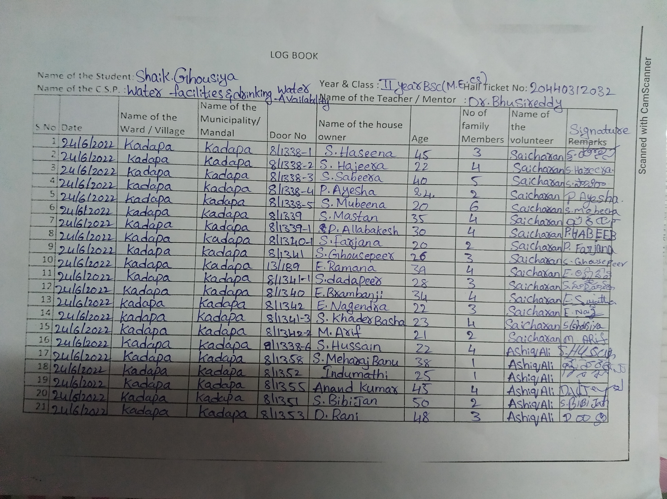

Results &Discussion :
- What water system do you have?
In survey, we observed that 57% of the people use central water and only 42%/ of the people use their own bore water.

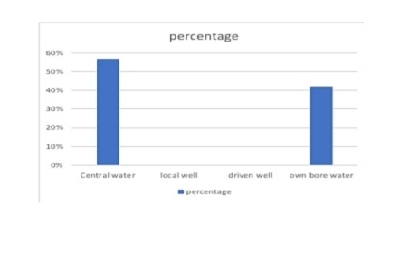

- Are you use the same water for both drinking and other purpose?
In survey, we observed that 57% of the people use separate water for both drinking and other purpose . Remaining 42% of the people use same water for both drinking and other purpose .

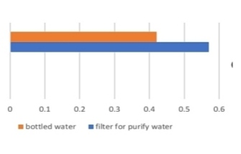

- If you use tap water, whether they supply daily (or) not? If not for how many days?
According to the survey, we noticed that, almost all the people use tap water and they told water will supply day after day.

- How many members are there in your family?
In survey, we observed that 28% of the people told 4 members are there in their family, 19% of the people told 6 members , 19% of the people told 6 members and 14% of the people told 10 members are there in their family.

- Is the water sufficient for your family?
According to the survey, we noticed that 100% of the people told water sufficient for their family.

- Do you experience water shortages?
According to the survey, we noticed that 52% of the people said that they never experienced water shortages, 38% of the people told some times they face water problem and remaining 9% of the people told they face water shortages almost every year.
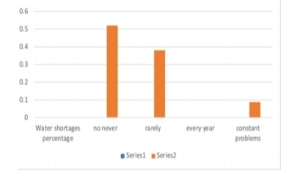

- How would you evaluate the quality of your drinking water?
In survey, we observed that 95% of the people told the quality of their drinking water is very good and only 5% of the people told they just satisfied with that water.
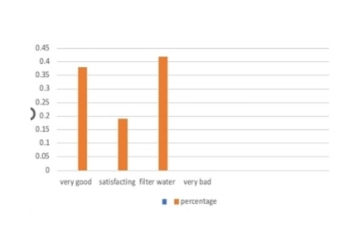

- Do you collect rain water for your household?
According to the survey, we noticed that on 5% of the people collect rain water for their household and remaining 95% don’t collect rain water for their household.

- Generally, what does the tap water look like?
In survey, we observed that 95% of the people told the tap water which they use is clear and only 5% of the people told the tap water which they use is cloudy (or) dirty.

- Do you pay water?
According to the survey, we noticed that 100% of the people paid for water.

- Overall, are you satisfied with your drinking water service?
In survey, we observed that 100% of the people told they satisfied with their drinking water service.

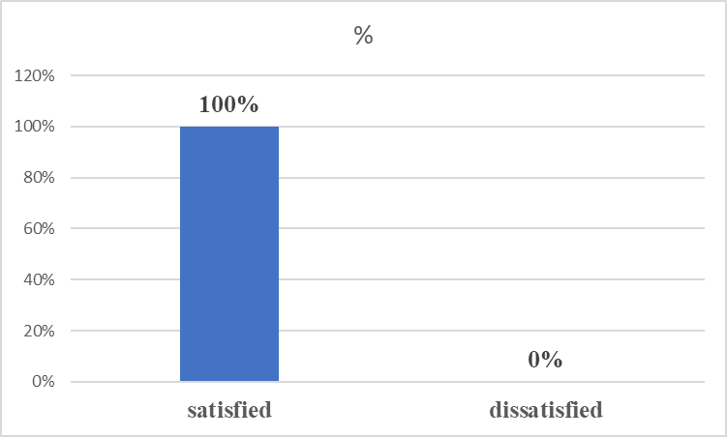

Conclusion:
As a part of Community Service Project, we explained to the people the importance of water in daily life and we suggested to the people, collect rain water for their household and construct ink holes in their families. Also suggested that don’t waste water .
In survey, we observed that most of the people use central water. Some people use the same water for both drinking and other purpose, maximum number of the people use separate water for drinking . Almost all the people told water will supply day after day and which is sufficient for their families. Maximum number of the people told they never face water shortages and some people face the water problem.Finally I noticed that maximum number of the people satisfied with their water facilities and drinking water availability.

Save water and Save life

Geotagged Photos

Orientation Programme to the Students on Community Service Project
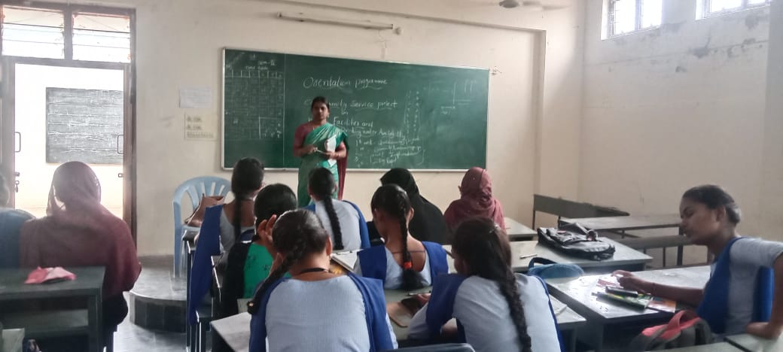

Survey at Ravindra Nagar, Kadapa
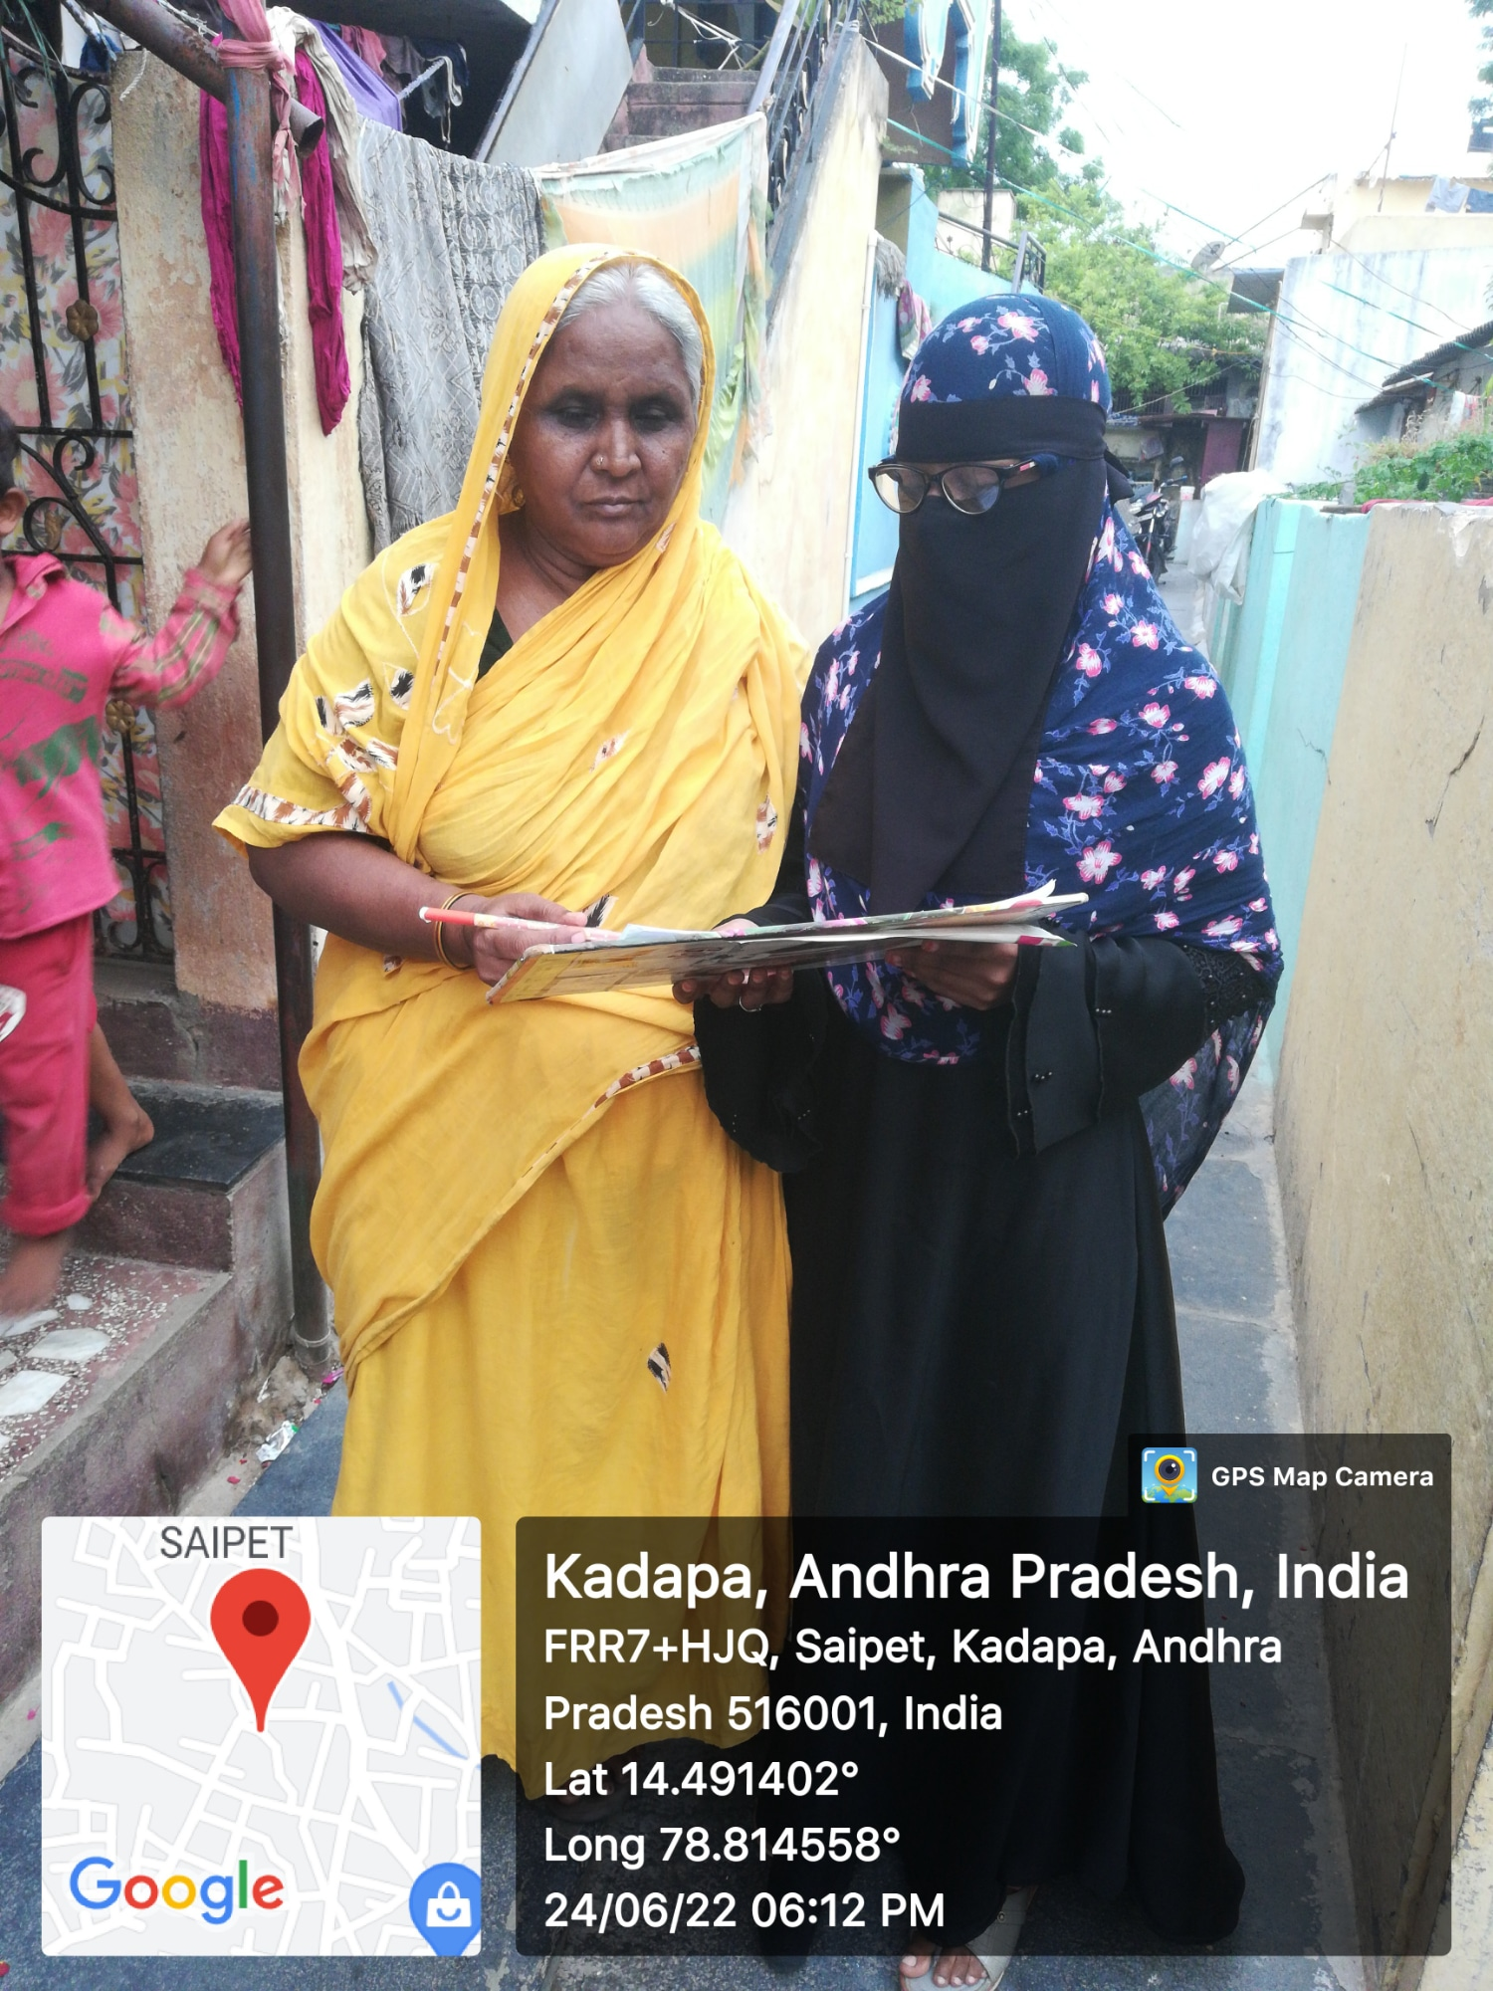
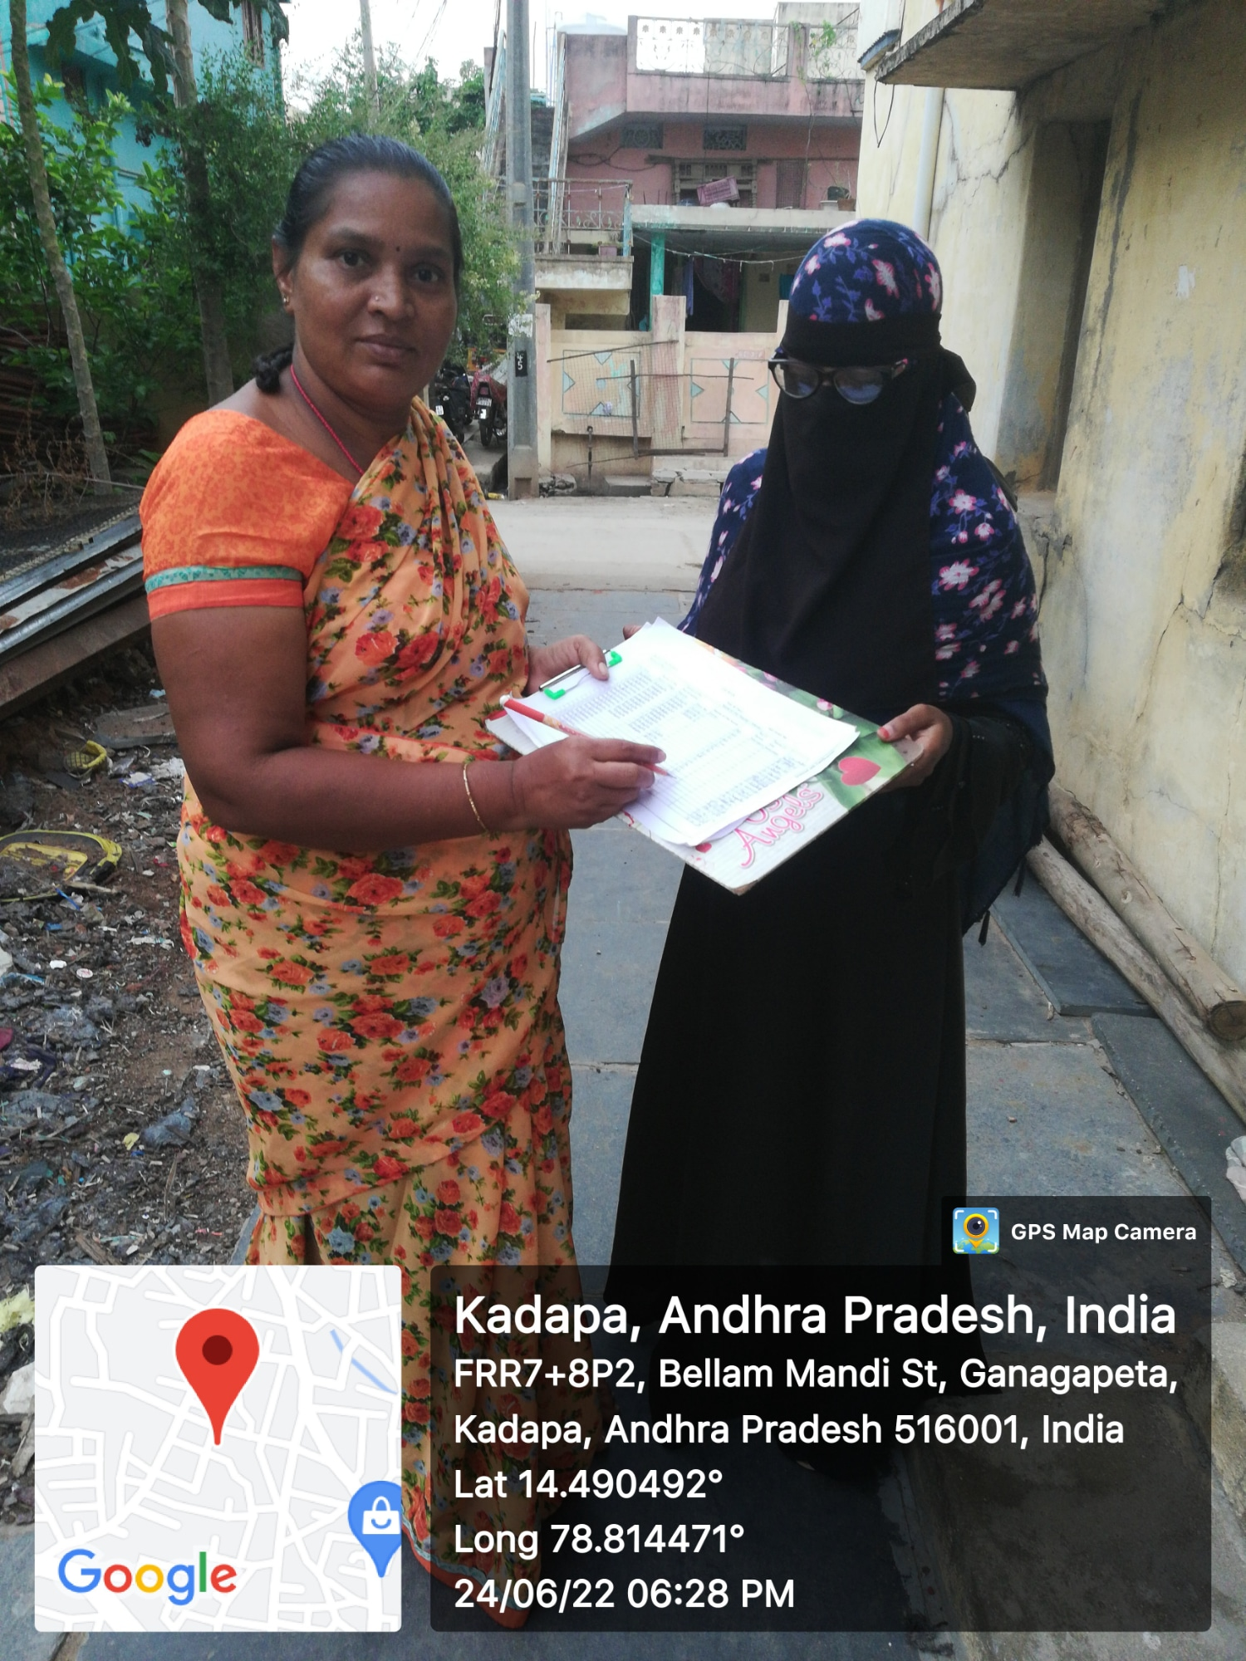

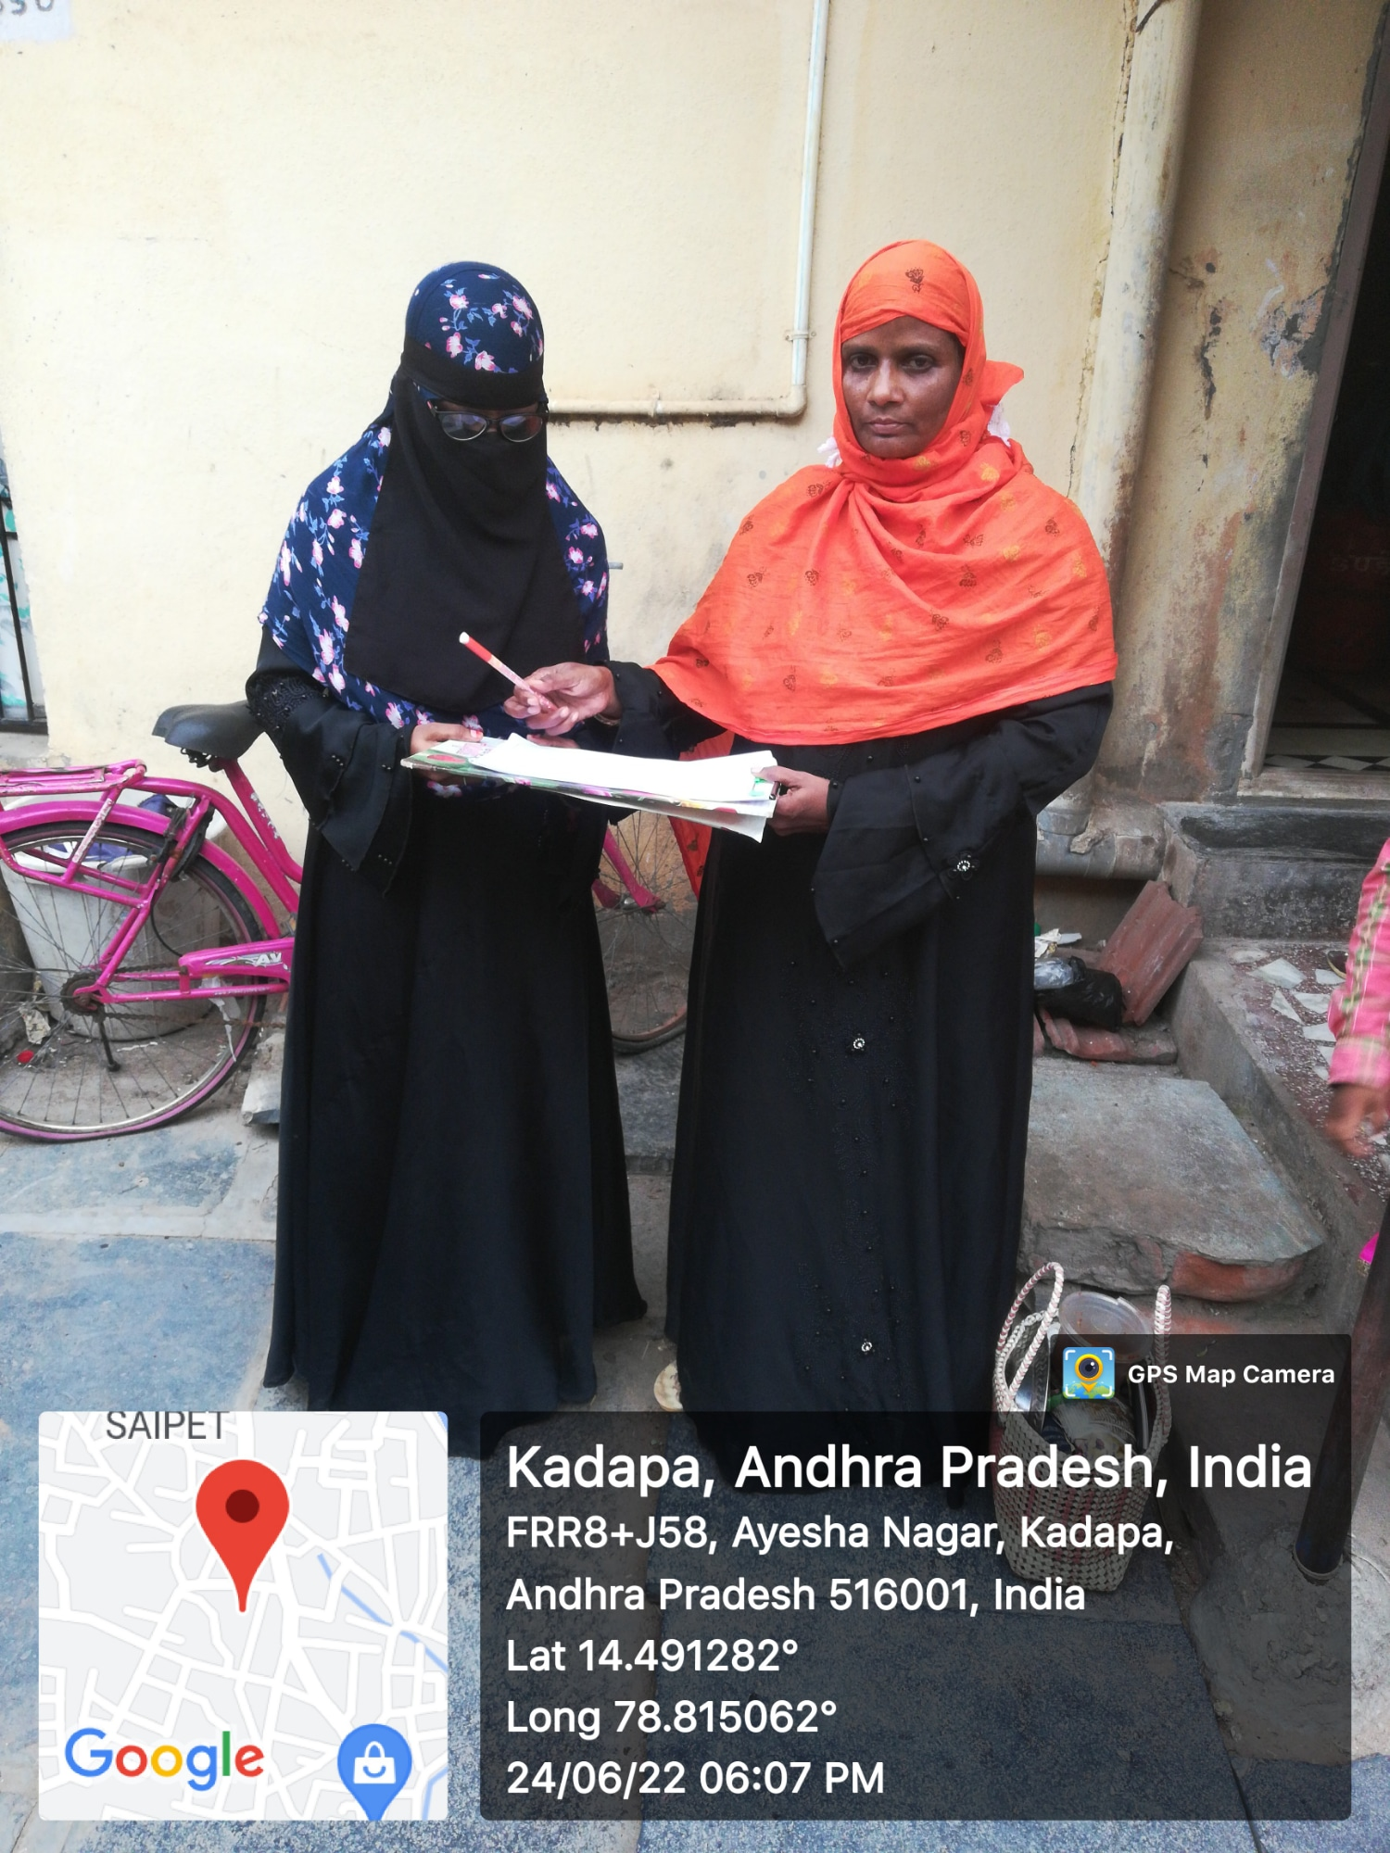
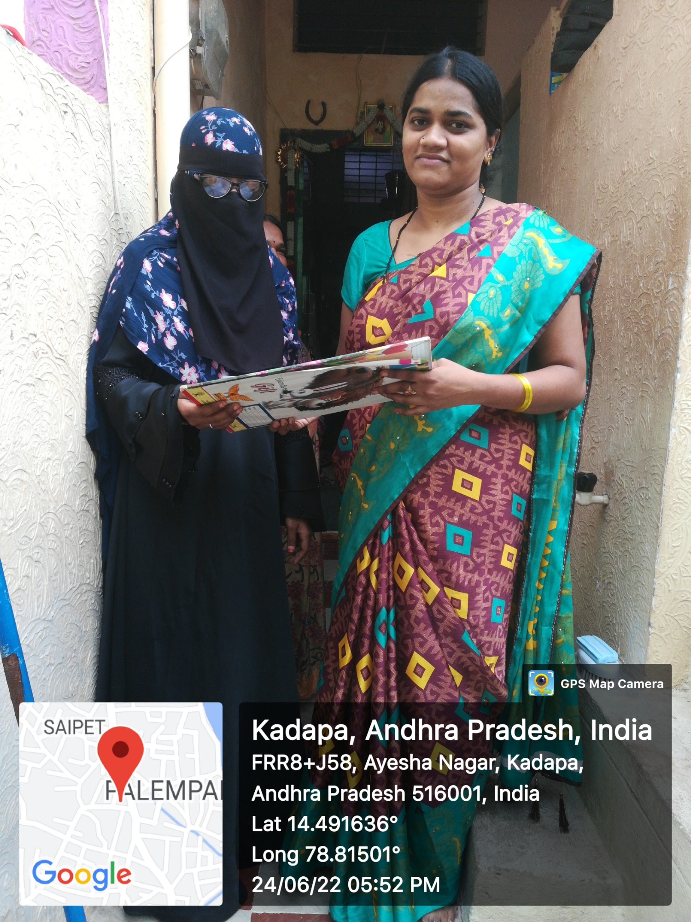

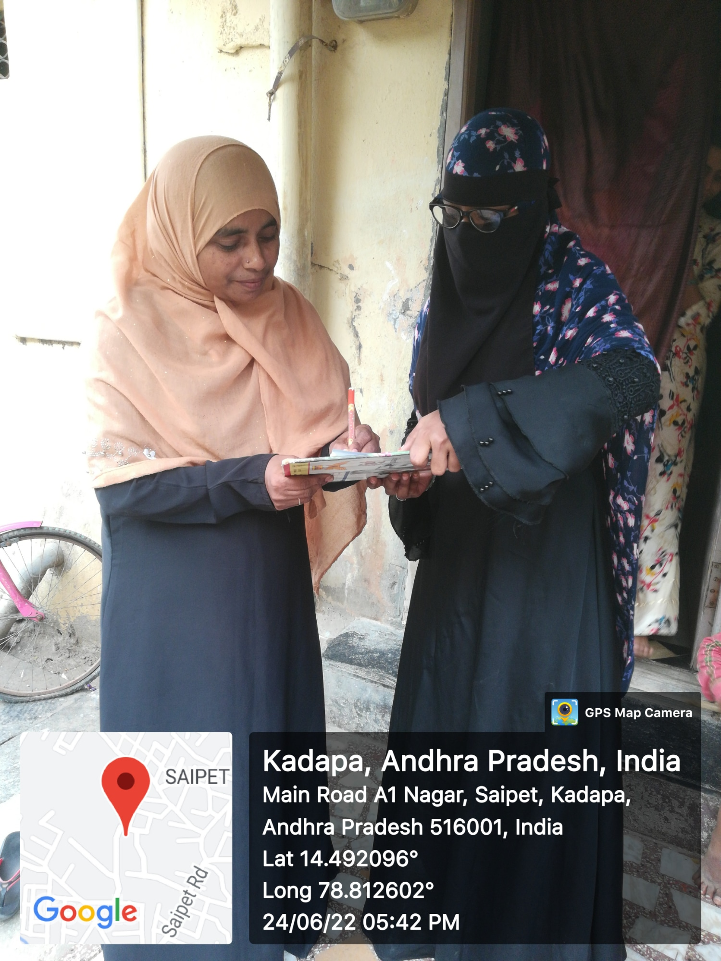
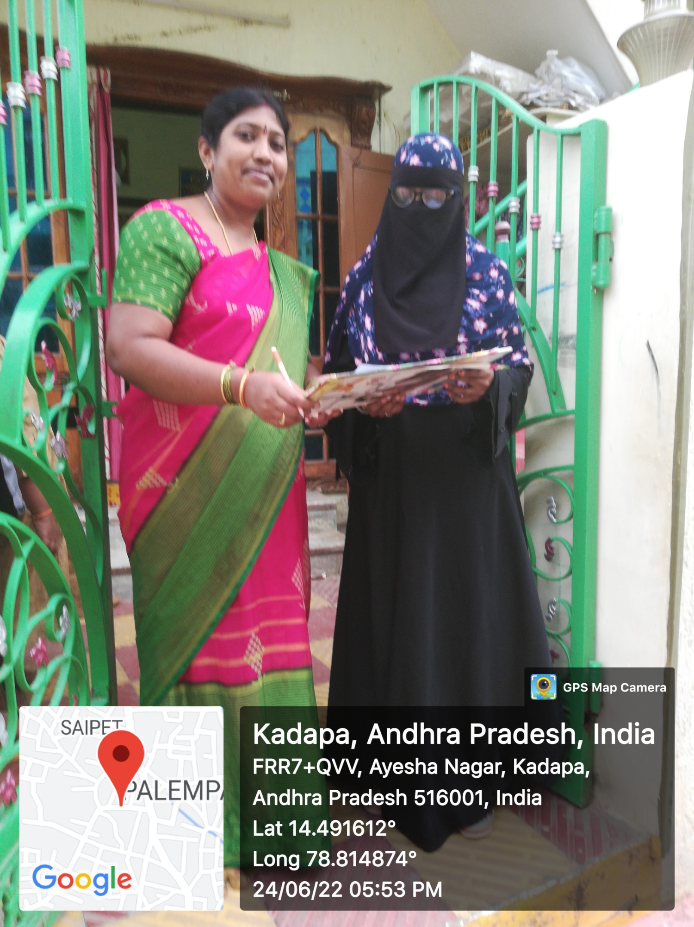
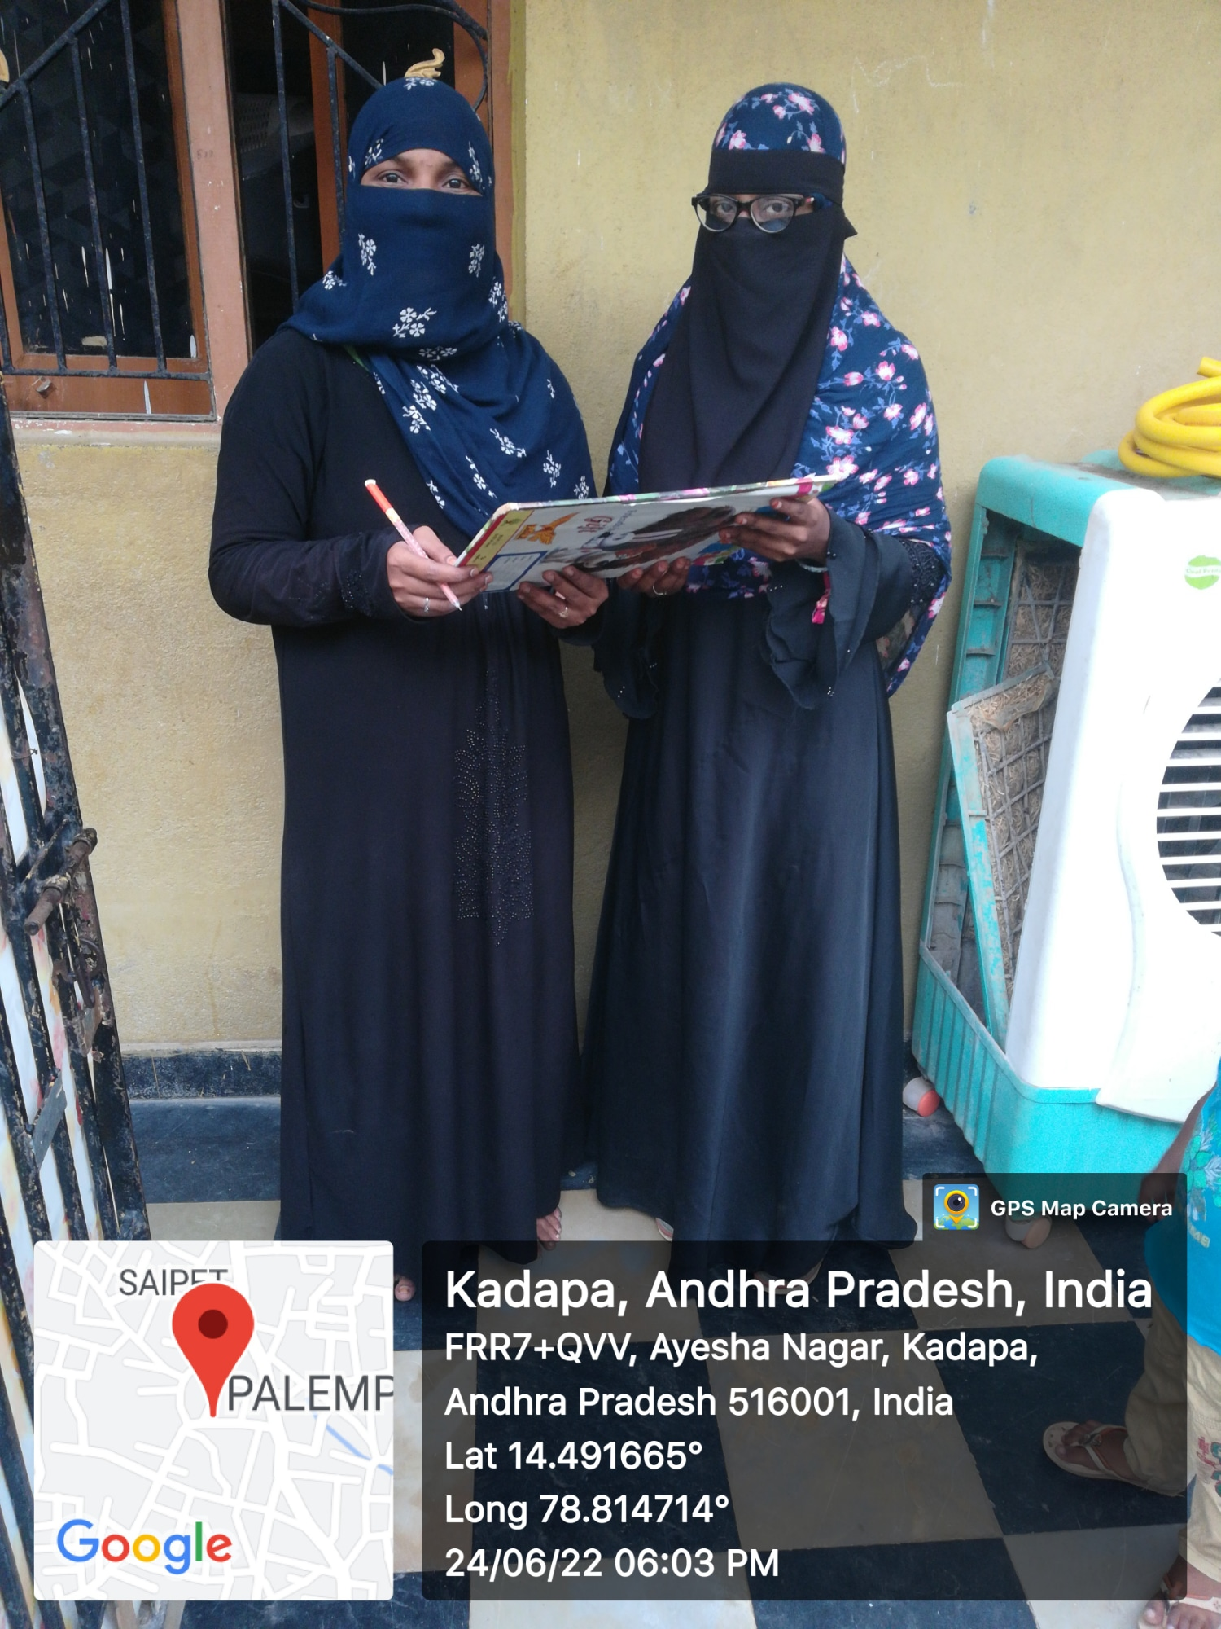

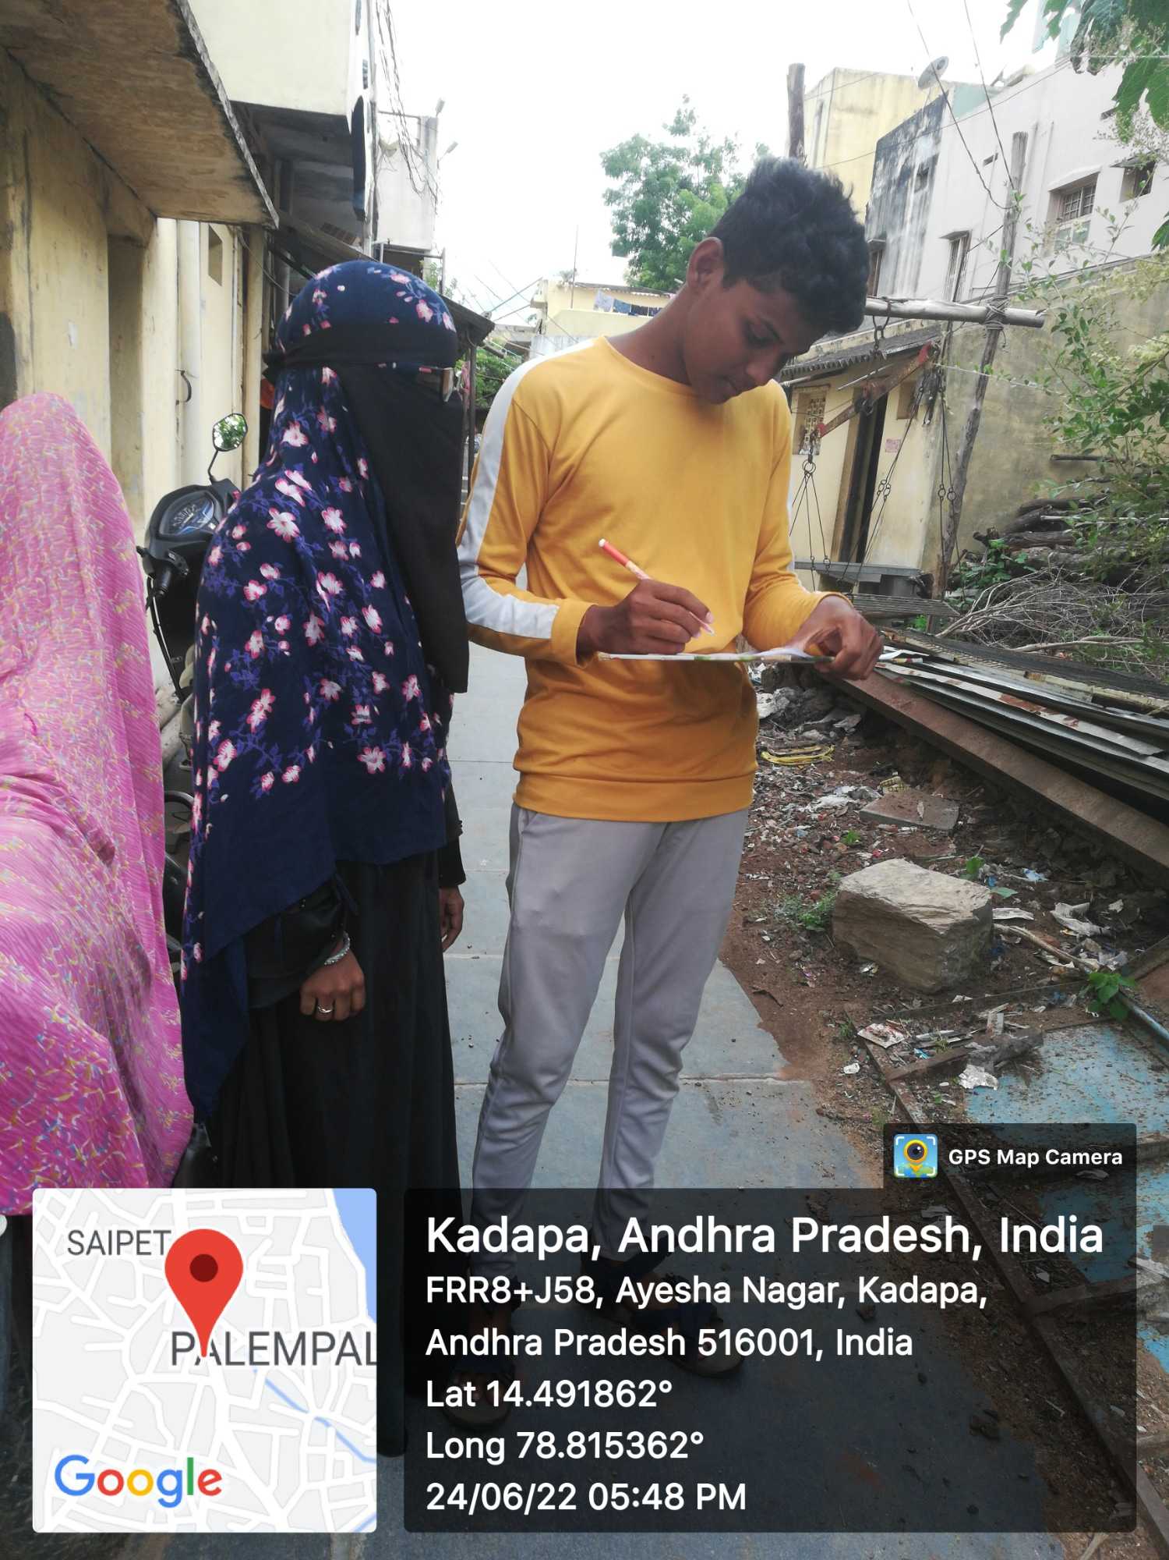

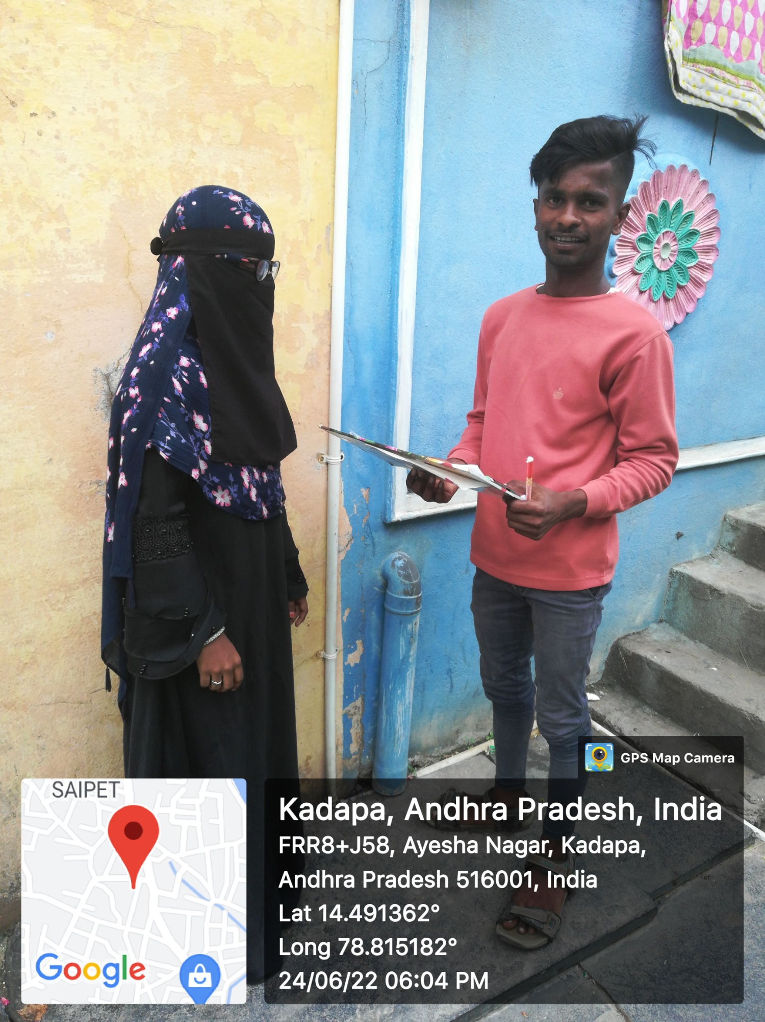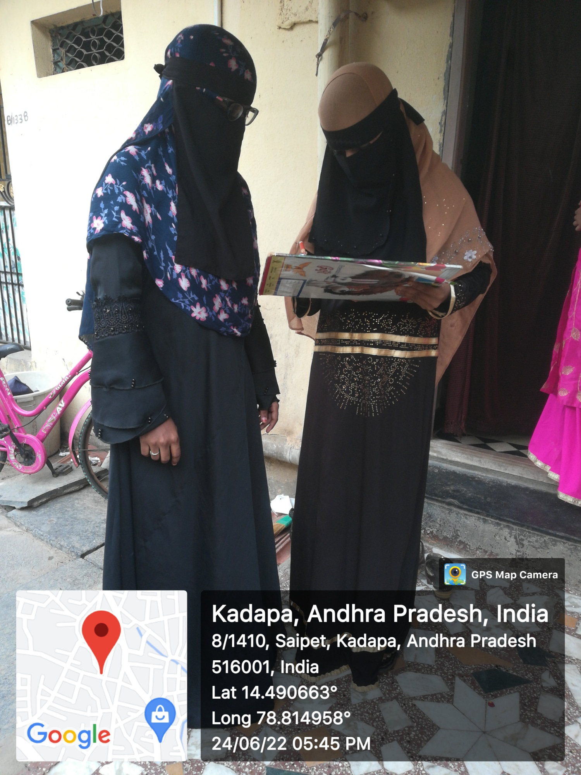

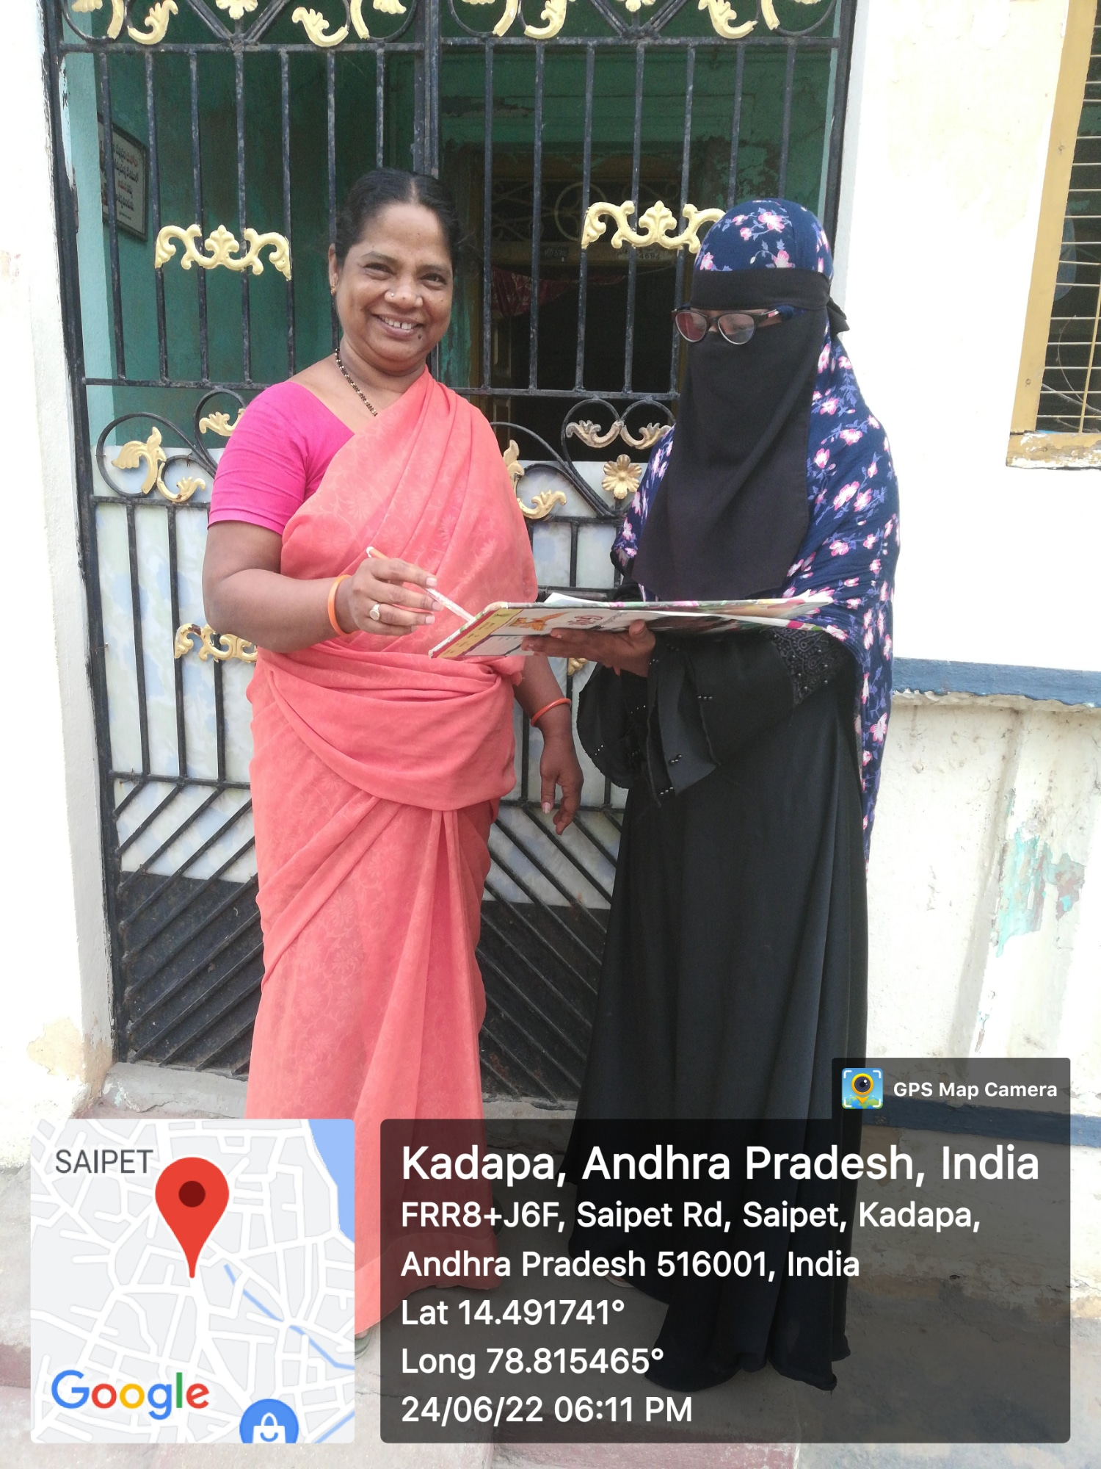

References:

- https://youtu.be/BFCtzoLWD7c

- https://youtu.be/BFCtzoLWD7c

- https://youtu.be/Xe4o3a_DtII

